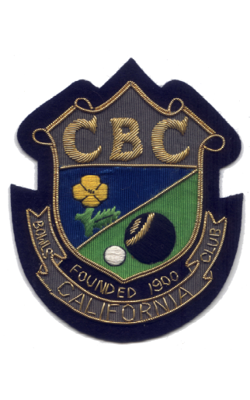

SAMFORD BOWLS LEAGUE

1988 | Division E.
1990 | Division C.
1993 | Division C.
1993 | Division G.
1994 | Division F.
1999 | Division A.
1999 | K. O. Cup.
2000 | Division A.
2001 | Division A.
2001 | K. O. Cup.
2002 | Division A.
2003 | Division A.
2004 | Division F.
2005 | Division E.
2006 | Division A.
2007 | Division C.
2007 | K. O. Cup (‘B’Team)
2008 | K. O. Cup
2010 | Millennium Trophy
2014 | K. O. Cup
2015 | Millennium Trophy
2017 | Division B (Afternoon League)

