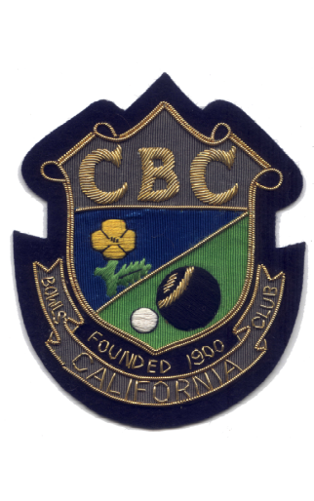

IPSWICH TRIPLES
BOWLS LEAGUE

1977 | Division B.
1991 | Division D.
1992 | Division C.
1993 | Division B.
2013 | Division C.
2016 | Division A.
2017 | Division A.

