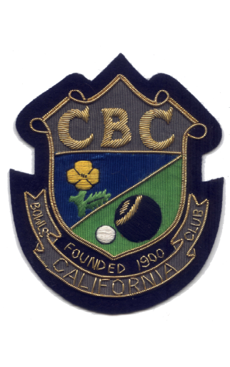

COUNTY TRIPLES CHAMPIONS

1927 | S.C.B.A. | Sun Bowl | W. Friend. W. Meadows. A. Gage.
1967 | S.C.B.A. | 2. Wood | S. Taylor, R. Martin, W. Flatt.
1970 | S.C.B.A. | 2. Wood | W. Wardley, S. Taylor. R, Harsant.
1978 | S.C.W,B.A. | 3. Wood | Mrs J. Payne, Mrs J. Davey, Mrs J. Allison
1986 | S.C.B.A. | 2. Wood | E. Gaynor, B. Cooper, J. Catchpole.
1988 | S.C.B.A. | 2. Wood | A. Roberts, C. Love, D. Cousins.
1990 | S.C.B.A. | 2. Wood | N. Coote, R. Kennedy, R. Simpson.
1991 | S.C.B.A. | Mixed | Mrs. A. Simpson, P. Wildon, R. Simpson.
1995 | S.C.B.A. | 3. Wood | N. Coote, R. Kennedy, R. Simpson.
2000 | S.C.B.A. | 3. Wood | I. Wiseman, C. Love, D. Cousins.
2003 | S.C.B.A. | 2. Wood | Ch. Wiseman, Co. Wiseman, A. Catchpole.
2004 | S.C.B.A. | Mixed | Mrs. P. Noble, K. Halls, S. Wildon.

