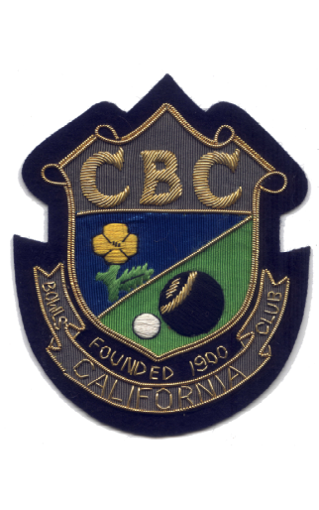

OFFICERS
1982 | President S.C.B.A. | G. Youngman.
1994 | President I & D.B. L. | D. Cable.
1995 | President S.C.W.B.A. | Mrs. J. Love.
1996 | President I & D. B. L. | C. Love.

