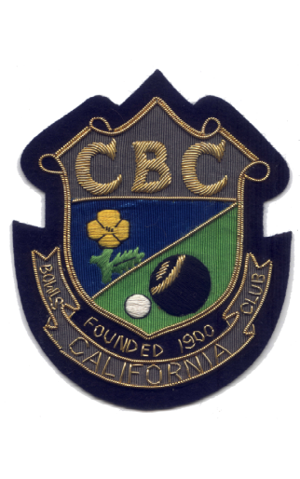

COUNTY TEAM CUPS
1960 | S.C.B.A. | Junior Cup
1973 | S.C.B.A. | Junior Cup
1994 | S.C.B.A. | Senior Cup
1996 | E.A.D.T. | (Mercury) Shield
1999 | E.A.D.T. | Charity Shield
2001 | S.C.(EBA)B.A. | Bert Edwards Fours
2002 | E.A.D.T. | Charity Shield
2002 | Area ‘C’ | Stan Wright
2003 | Area ‘C’ | Stan Wright
2004 | Camel | Charity Cup
2005 | Camel | Charity Cup
2005 | S.C.(EBA)B.A. | Norton Cup
2006 | S.C.(EBA)B.A. | Norton Cup
2006 | S.C.(EBA)B.A. | Millennium Trophy
2006 | S.C.(EBA)B.A. | Bert Edwards Fours
2006 | S.C.B.A. | Senior Cup
2007 | Daniel’s | Charity Plate
2007 | S.C.B.A. | Champions Trophy
2008 | S.C.(EBA)B.A. | Millennium Trophy
2010 | S.C.(EBA)B.A. | Bert Edwards Fours
2011 | S.C.(EBA)B.A. | Quinton Bowl
2014 | Area ‘C’ | Stan Wright
2014 | Marie Curie | Plate
2015 | S.C.B.E. | Quinton Bowl
2017 | S.B.(B.E.) | Bert Edwards Fours
2017 | S.B.(B.E.) | Millennium Trophy
2018 | S.B.(B.E.) | Bert Edwards Fours

