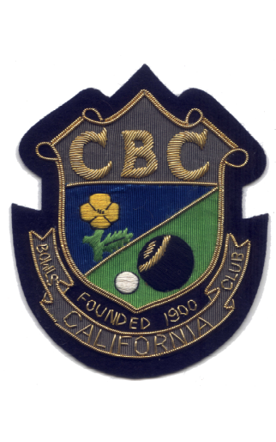

SUFFOLK COUNTY MIXED FOURS BOWLS LEAGUE

2009 | Section.
2009 | County.
2010 | Section.
2010 | County.
2011 | Section.
2011 | County.
2012 | Section.
2012 | County.
2014 | Section.
2018 | Section.

