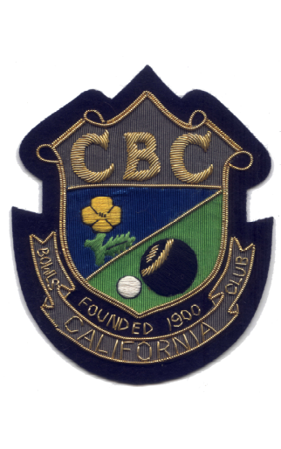

COUNTY SINGLES
CHAMPIONS
1930 | S.C.B.A. | 2. Wood | W. Friend
1964 | S.C.B.A. | 2. Wood | R. Martin
1966 | S.C.B.A. | Under 25’s | R, Hambling
1967 | S.C.B.A. | 2. Wood | R. Hambling
1976 | S.C.B.A. | 2. Wood | R. Martin
1978 | S.C.B.A. | Under 25’s | P. Allen
1990 | S.C.W.B.A. | C of C | Mrs. J. Love
1993 | S.C.W.B.A. | Secretary’s | Mrs. J. Love
1994 | S.C.W.B.A. | Secretary’s | Mrs. J. Love
1995 | S.C.W.B.A. | Novices | Mrs. E. Nunn
1996 | S.C.B.A. | 2 Wood | I. Wiseman
1997 | S.C.W.B.A. | Senior | Mrs. J. Love
1998 | S.C.B,A. | 4 Wood | I. Jay
1999 | S.C.(EBA)B.A. | 4 Bowl | C. Love
2004 | S.C.B.A. | 2 Wood | Ch. Wiseman
2007 | S.C.B.A. | 4 Wood | K. Bassett
2009 | S.C.W.B.A. | 2 Wood | Mrs. J. Paternoster
2010 | S.C.(BE)B.A. | 4 Bowl | S. Wildon
2011 | S.C.B.A. | 2 Wood | B. Green
2012 | S.C.(BE)B.A. | Novices | L. Powell
2013 | S.C.(BE)B.A. | Novices | A. Turner

